

REQUIREMENTS DOCUMENT | VERSION 1.0

TVL Enterprise Website Redesign

TVL Enterprise Website Redesign

Table of Contents

|  |  |
| --- | --- |
| Overview | 3 |
| Global | 5 |
| Homepage | 7 |
| Get Started and About Pages | 9 |
| Product Gallery Landing Page | 10 |
| Product Gallery | 11 |
| Product Detail Pages | 13 |
| Product Compare | 15 |
| Inspiration Gallery | 16 |
| Budget Estimator | 17 |
| Favorites | 18 |
| Locator | 19 |
| Sitecore Enhancements & Content Entry | 20 |
| Phase 2 | 22 |
| Global | 23 |
| Mega-Menu | 24 |
| Our Products Landing Page | 25 |
| Product Category Landing Pages | 26 |
| Product Gallery Enhancements | 27 |
| Acceptance Sign-off | 29 |

|  |  |  |  |
| --- | --- | --- | --- |
| date | **November 1, 2018** | requirement no. | **TVL Enterprise-01** |
| creator | **Heather Wigand** | ticket no. | **N/A** |
| analyst | **TBD** | requested date | **TBD** |
| owner | **Brian Taylor** | application | **Sitecore** |
| function | **Marketing** | reason | **Rebranding** |
| customer | **Web Marketing** |  |  |

The requirements in this document are for representation on how the updated Thomasville (.com) and Thomasville (.ca) websites will look andfunction in order to support rebranding, as well as accommodate an additional product offering, Artisan (.com only).

Significant Features

Content: What is on the page.

Format: How an item is represented.

Technology: Behaviors and formats.

Grouping: Items are set apart by visual dividers.

Hierarchy: The consistency of the overall ordering and structure.

Behavior: How something responds to user interaction.

Insignificant Features

Wording: Suggestions of concept only.

The requirement is based on MasterBrand Cabinets Inc. knowledge to date.

**CONFIDENTIALITY STATEMENT**

This document contains proprietary information. ALL INFORMATION CONTAINED HEREIN SHALL BE KEPT IN CONFIDENCE. None of this information shall be divulged to persons other than MasterBrand Cabinets Inc. employees, individuals or organizations authorized by MasterBrand Cabinets Inc. in accordance with existing policy regarding release of company information.

Overview

Scope

The thomasvillecabinetry.com and thomasvillecabinetry.ca websites need updated styling to support rebranding, as well as accommodate the additional Artisan series product offering (.com only).

Business Goals & Objectives

1. Introduce a premium series (Artisan) to thomasvillecabinetry.com
2. Refresh and improve the thomasvillecabinetry.com and thomasvillecabinetry.ca web experience while aligning with brand standards

Process Change

No. The TVL website is already supported by Web Marketing through the Sitecore Content Management System.

Test Scenarios & Testers

|  |  |
| --- | --- |
| testers | **Heather Wigand, Brian Taylor, Matt Courtney** |
| environment | **Developer Environment(s), D01, T01, CM, PROD** |
| data | **Content** |

Maintenance

Maintenance would be the same as it is for any other brand site in Sitecore.

Change Management Review Required

Yes

Overview (cont.)

Domains

D01 **d01.thomasvillecabinetry.com / d01.thomasvillecabinetry.ca**

T01 **t01.thomasvillecabinetry.com / t01.thomasvillecabinetry.ca**

CM **cm.thomasvillecabinetry.com / cm.thomasvillecabinetry.ca**

PROD **www.thomasvillecabinetry.com / www.thomasvillecabinetry.ca (and non-www redirects)**

Assumptions

* MBCI Sitecore (version 8.1) environment will be used
* Content and functionality of the site will be identical to that seen on the current Thomasville sites with exceptions noted within this requirements document
* Sitecore language versioning will continue to be used as it is today to vary the content between sites: ThomasvilleCabinetry.com, ThomasvilleCabinetry.ca and ThomasvilleCabinetry.ca in French. All newly added templates and fields will be developed in a way to handle the versioning that is currently in place.
* Marketing content will be ready for use
* Relationship with front-end design and back-end development agencies will be smooth
* Content manageable field values will not be hardcoded, updating these fields will not break any functionality on the page.
* The content management will be intuitive to the content author:
  + Fields that are not being used will be removed, content management practices will align with our other brand sites, presentation details will not be used by content authors unless absolutely necessary, etc.
* Web and Sitecore best practices will be followed:
  + Not using capital letters in URL’s, link targets work as expected when set in Sitecore, etc.
* Content will not be lost during deployments

Out of Scope

* Marketing Automation and Sitecore DMS tracking and communication tools
* Non-admin user authentication (SSL, logins, etc.)

Global

**DEVICES/OPERATING SYSTEMS/BROWSERS:**

1. The sites will function and render as designed on the following devices: Smartphones, tablets, Ultrabook/hybrids, laptops, desktops.
2. The sites will function and render as designed on the following operating systems: iOS6+, Android 4+, Windows 7-8.1, OS X.
3. The sites will function and render as designed on the following browsers: IE11+, Microsoft Edge, Safari Mobile, Safari (current), Chrome Mobile, Chrome (current), and Firefox (current).
4. Recognized older browsers should have an on-screen message presented to the user that is obvious, but not annoying or disruptive, alerting the user that the best experience on the sites requires a newer browser version and directs them to an appropriate place to upgrade. Something like updatemybrowser.org provides in their widget, but with a custom message that is friendlier and branded so there is no confusion that the message is from these websites.

**UX / DESIGN:**

1. The colors, fonts and overall styling of **ALL PAGES** on the site will need to be updated to align to Thomasville standards.
2. Visual design will be needed for the following redesigned/enhanced pages, **versioned for .com and .ca where noted**:
   1. Homepage (.com and .ca)
   2. Product Gallery Landing Page (.com and .ca)
   3. Product Gallery
   4. Product Detail – Door and Finish or Secondary Product
   5. Product Compare – Door and Finish
   6. Get Started and About
   7. Budget Estimator 4th step, updated budget estimator results screen and PDF
   8. Favorites
   9. Locator
3. All existing pages should continue to follow best practices for responsive web design, as well as any new pages that are developed.
4. The design of the sites should continue to allow for up to 7 main navigation items.
5. If global elements are updated in the designs on any of the above pages it will be expected that those elements are updated on ALL pages throughout the site, even if those pages are not noted above. Global element examples: CTA’s, Footer, Header/Navigation, Fonts, Share, Favorite, etc.
6. Designs to be mocked up on actual device screens to accurately depict page width.

**ANALYTICS & REPORTING:**

1. Visitor reporting will continue through the Google Analytics code within the existing Google Tag Manager implementation for the sites.
2. Any event tracking already in place, like for the door visualizer, should be retained and still report data accurately after the redesign.

Global (cont.)

**SEO, CONTENT & SOCIAL SHARING:**

1. All content from the current Thomasville (.com) and Thomasville (.ca) sites should be unaffected by these updates, unless otherwise noted in this document.
2. The site should be indexible by search engines, given basic best practice code development.
3. Traditional SEO tags should continue to be manageable through the CMS (browser title, description, keywords, no-index, no-follow, canonical).
4. Robots.txt and XML sitemap files should continue to be manageable within the CMS as well.
5. Sharing tools should support visual creative and perform consistently with how they function on the sites today.
6. All pages should have an H1 heading on all breakpoints.

**CONTENT MANAGEMENT / PRODUCT CONFIGURATION CHANGES:**

1. Door styles, finishes, secondary products and rooms should allow for association to a series and associated iconography should present within the UX as is on the current site today.
2. TVL will need functionality like the DAL site in order to have penned and hand wiped glazes managed separately from finishes (called detail and artisan glazes for DAL). The will also need additional categories for specialty, brushed and semi translucent finishes. The TVL door detail pages should be able to have up to 7 finish categories. Those 7 categories will be: finish, color, penned glazes, hand wiped glazes, specialty finishes, brushed finishes and semi-translucent finishes.
3. Product detail pages will need to have a separate area for finish options not available for visualization, like penned glazes, specialty finishes, etc. When swatches in that area are clicked, the image should enlarge instead of changing the door image (like current DAL product detail pages).
4. All content on the sites should be able to be versioned for .com and .ca as it is today.
   1. .com – English : English
   2. .ca – English (Canada) : English (Canada)
   3. .ca in French – French (Canada) : Francais (Canada)

**PERFORMANCE:**

1. Site performance should be on par or better than recently launched websites.
   1. We have observed suboptimal performance for this particular site prior to this project.
2. Caching, GZIP compression, Expires Headers, and Etags should be turned on for the server/files.
3. Automatic combination and minification should be applied to HTML, CSS, and JavaScript.
4. All non-content-entered images should be saved to ensure that META data (EXIF or similar) is not present in the files.
5. Refer to “MBCI Brand Site Performance Tools & Expectations.docx” document for additional details on performance expectations.

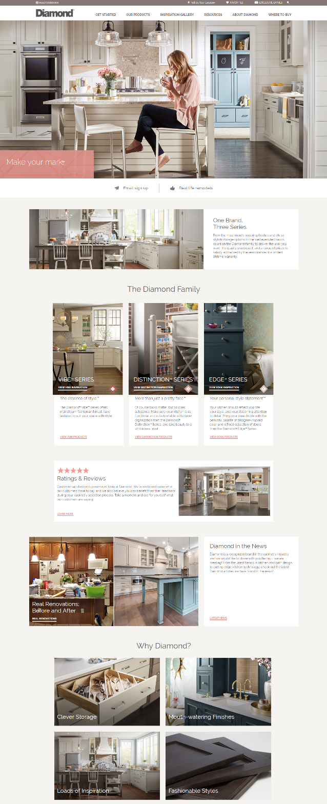Homepage (.com and .ca)

**Front-End Acceptance Criteria:**

1. The updated TVL websites will utilize a new homepage design in a long-scroll format that reflects a ‘content pod’ layout similar to Diamond as well as the colors and styling of TVL.
2. The ‘language switcher’ that is optional for the .ca website should be included in the .ca Homepage designs.
3. A new utility navigation banner should be added to the top of the TVL websites. This banner would need to include Favorites, Search, The Home Depot logo, the MBCI logo and the language switcher (.ca only). The content author should be able to ‘turn off’ the MBCI logo if they choose. Ideally if that logo field is blank the MBCI logo will not show.
4. The hero carousel/primary navigation/utility navigation area for TVL will need to be expanded to full width (to a certain breakpoint) like Diamond. The width of the overall homepage width should be updated accordingly
   1. Would like to see different treatment for the text call out/CTA over top the hero carousel, the white text over an image can be hard to read.
   2. Carousel should be able to have one or many rotating images as it does today.
5. Beneath the hero carousel we would like an area for up to thee ‘call out item s’ like Diamond shows on the right. These items should have content manageable icon, text and link. The items that will likely live here are:
   1. Track My Order, Promotion and Order a Sample
6. The homepage will need to support various content pods:
   1. Simple image/copy content pod – this pod should be able to support an image, headline, body copy and an optional CTA.
   2. Series call-out pod – this pod will need to include all series offered on that site (4 for .com and 2 for .ca). These pods will be used to introduce the series to the user. Each series content area should be able to support an image, series name, series tagline, copy, series icon and an optional CTA.
   3. Ratings and reviews pod – this pod should be able to support a headline, star image, beauty image, copy and an optional CTA.
   4. ‘Real Renovations’ content pod – this pod should be a two column pod which supports an image, headline and optional CTA on the left, and a headline, copy and optional CTA on the right.
   5. Four block content pod (like ‘Why Diamond?’) – This pod should support a pod headline with 4 images, each image should have a headline and an optional CTA link.

3.

2.

*DiamondCabinetry.com shown to the right for reference ONLY. TVL to have its own unique designs created during this project.

6e.

6d.

6cc.

6b.

6a.

5.

4.

Homepage Cont. (.com and .ca)

f. Mixed media content pod – this pod should be able to support 4 different types of content. All pods should be able to support an image, headline and optional CTA. Once pod should also support marketing copy, and another pod should be able to support a video.

g. Pinterest content pod – this section should be able to support a widget such as Pinterest.

7. The Home Depot CTA banner – This banner will need to remain on the TVL.com and TVL.ca homepage (Currently shown on thomasvillecabinetry.com)

8. Footer – The footer can remain as is except we will need to add in the ‘MasterBrand family’ logo and MasterBrand address like Diamond. Also keep the TVL logo in the footer.

9. We would like to have newly designed CTA’s for the website. We would like to see a ‘button’ style CTA and a ‘link text’ style.

**Back-End** **Acceptance Criteria:**

1. All elements and content on the page should be content manageable in Sitecore.
2. The links shown underneath the hero carousel should be optional; if there are none selected to appear, that section should not show beneath the carousel.
3. Content pods should have the ability to be moved around on the homepage; development should not assume that they will always be in the order/location that they are shown in the designs.
4. The ability to put promotions in the hero carousel or within the body of the homepage will be needed.
5. The content author will need the ability to turn on/off all pods on the homepage.
6. Content pods should be able to be replicated and used more than once if desired.
7. If there isn’t a CTA link specified for a section, no CTA link should show up on the page.
8. The heading shown on the hero image will serve as the H1 of the page.
9. Must maintain ability to have varying content between the .com and .ca homepages. All language versioning should remain in place and should function on all newly added templates/fields.
   1. .com – English : English
   2. .ca – English (Canada) : English (Canada)
   3. .ca in French – French (Canada) : Francais (Canada)

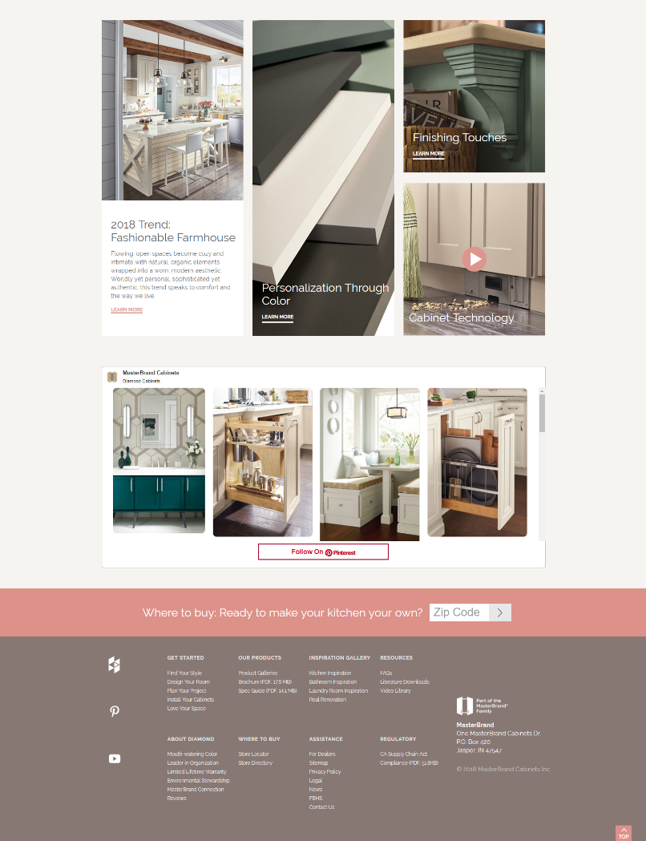

6g.

*DiamondCabinetry.com shown to the right for reference/context ONLY. TVL to have its own unique designs created during this project.

6f.

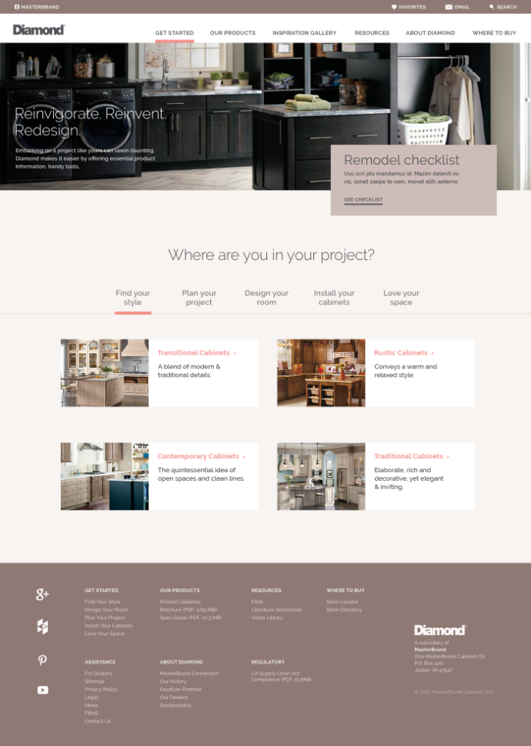 Get Started and About Pages (.com and .ca)

**Front-End Acceptance Criteria:**

1. In addition to the design changes needed to the homepage, the Get Started and About pages will also inherit a new look and feel as part of this redesign.
2. When a user first arrives to the Get Started page, they’ll see the Find Your Style section selected, with content showing for each of the four design styles.
   1. Clicking the one of the links in this section should take the user to the content page associated to that design style.
3. When the user selects Design Your Room, or any of the other sections of Get Started, they’ll see a list of the pages within that section only, similar to the design of the Diamond Get Started page. These ‘tabs’ should be updated to function like Diamond, vs the long scroll.
4. Remove the circular image of the woman on the TVL Get Started page and replace it with a Remodeling checklist content area similar to Diamond.
5. The About page should look/function like Get Started, with a couple exceptions:
   1. Rather than being a list of links like most of the Get Started content, the content within each tab of the About page will primarily be text (some images as needed) like the Diamond About page.
6. The header banner images and text treatment can remain the same for the Get Started and About pages as to remain consistent with the general content pages.

**Back-End** **Acceptance Criteria:**

1. All elements and content on the page should be content manageable in Sitecore.
   1. This includes the Remodeling Checklist item, which should be able to be turned on and off by the content editor.
2. The About page content should be managed similarly to content pages, with a rich text editor that will allow copy and images to be placed within the content area of each tab. (similar to Diamond)
3. Must maintain the ability to have varying content between the .com and .ca pages.

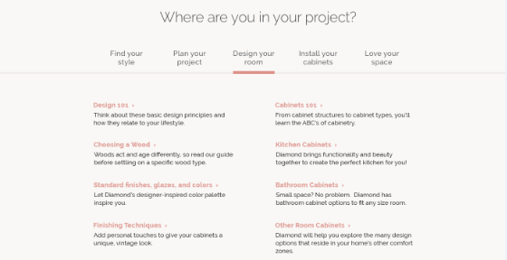

*DiamondCabinetry.com shown to the right for reference/context ONLY. TVL to have its own unique designs created during this project.

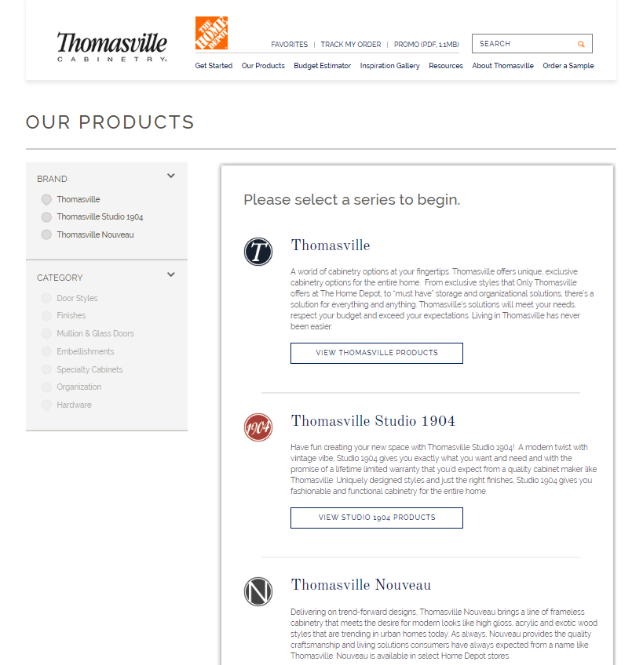Product Gallery Landing Page (.com and .ca)

**Front-End Acceptance Criteria:**

1. The newly designed product gallery landing page should overall be more image focused and contain less copy.
2. The purpose of this page is to give the user a brief overview of each series/brand.
   1. .com will have 4 series on this page and .ca will have 2
3. This page should contain a headline.
4. Each series content area should include an image, series name, series icon, marketing copy and a CTA that links to a pre-filtered gallery of products for that particular series.
5. Remove the Nouveau locator CTA from this page.
6. The Brand and Category filters should remain in the left rail of this page.

**Back-End** **Acceptance Criteria:**

1. All elements and content on the page should be content manageable in Sitecore.
2. All functionality that is in place today should remain as is.
3. Thomasville, Thomasville Studio 1904, Thomasville Nouveau and Artisan will appear for TVL.com
4. Thomasville Classic and Thomasville Nouveau will appear for TVL.ca as it does today.

*The requirements for this page are not needed if the Phase 2 requirements are to be delivered at the same time as the Phase 1 requirements.

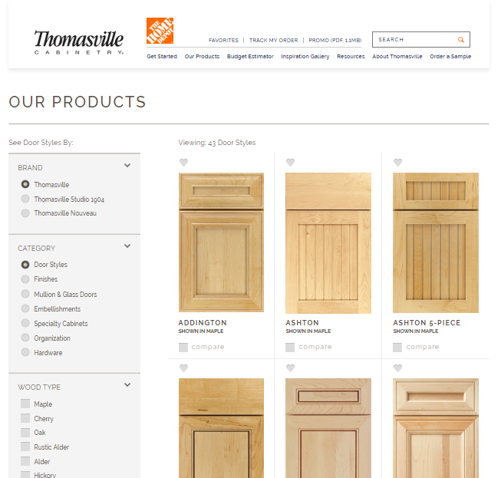Product Gallery (.com and .ca)

**Front-End Acceptance Criteria:**

1. A fourth brand/series ‘Artisan’ will be added to ThomasvilleCabinetry.com.  **This series will only be available on the .com site, not the .ca site.** **The TVL.ca product offering will remain as it is today.**
   1. Artisan doors should not appear anywhere on the .ca site (product gallery, inspiration gallery, finish detail pages, etc.)
2. Iconography will be present for the different series offerings and should have the hover state functionality. (this functionality is already in place for the existing series, will need to persist for new series)
3. Secondary product categories will stay consistent with what is currently on the TVL sites.
4. Sorting functionality will be introduced at the top right corner of all product galleries. The sort options should be the following within each gallery:
   1. Door Styles
      1. Most Popular, Newest, A-Z, Z-A, Simple to Ornate, Ornate to Simple, Price: High to Low, Price: Low to High
      2. Most Popular should be the default sort
   2. Finishes
      1. Light to Dark, Dark to Light, Most Popular, Newest, A-Z, Z-A
         1. *Finishes will be managed at a finish level only, not specie-finish level.
      2. Light to dark should be the default
      3. Sorting will be applied within the current finish category types (ie. Maple Finishes would show light to dark, then Maple Colors light to dark, etc.)
   3. Mullion and Glass, Embellishments, Specialty Cabinets, Organization and Hardware
      1. Most Popular, Newest, A-Z, Z-A
5. We will want to add another ‘Type’ within the finishes gallery called ‘Specialty’ this will be in addition to Finishes, Colors and Glazes.
   1. In order to do this I believe we will need to add a new folder within the Global area Global > Attributes > Options > Specialty to house these finishes.
6. Like filters, the user’s sorting selection should persist when they return to the gallery.
7. A user should only have to select the “Show More” button once. After that, subsequent pages should utilize lazy load functionality.

Product Gallery (.com and .ca) Cont.

**Back-End** **Acceptance Criteria:**

1. TVL currently uses hash links for the different categories (<http://www.thomasvillecabinetry.com/products#finishes>) whereas Diamond uses directories (<http://www.diamondcabinets.com/products/finishes>). The newly designed TVL sites should be updated to use the directories as Diamond does today. Each product gallery should have its own content manageable H1 like Diamond.
2. There will need to be a way to hyperlink users to pre-filtered galleries for a specific series with multiple filters applied. I should be able to link to any and all pre-filtered product galleries I choose with any combination of filters applied. For example, Studio Door Styles Maple Cherry Full Overlay, or Nouveau Finishes Maple Colors Light.
3. There will also need to be a way to link users to pre-sorted product galleries as well. For example, ‘See Newest Studio Door Styles’ would take the user to the Studio door style gallery with the Newest sort filter applied.
4. The content editor should be able to manage the order the finish categories display in the finishes gallery (the actual content, not just the filter options). (Stains, Colors, Glazes for example) Ideally this would be as simple as changing the order of the items in the Global folder.
   1. For example, currently when you look at the finishes gallery the Maple Finishes category shows up first, then Maple Colors then Maple Glazes…Ideally it would be Maple Colors, Maple Finishes, Maple Glazes.
5. The Artisan series should not appear on the .ca site anywhere.
   1. This includes the product gallery, finish detail pages, compare, inspiration gallery, favorites, etc.
6. The finishes in the finishes gallery should have the ability to be ordered from light-dark, this should be the default view, not alphabetical.
   1. The list will be managed at a finish level, not a specie-finish level.
7. There will need to be a way to manage the most popular, simple to ornate, ornate to simple, light to dark, dark to light, price low to high, price high to low, etc. Ideally these will be multiselect boxes that can easily be ordered.
   1. The newest sort can use sitecore’s created date like is used for the Diamond dealer door styles.
8. The content author will need the ability to choose/change the default sort for each product gallery.

Product Detail Pages (.com and .ca)

**Front-End Acceptance Criteria:**

1. In addition, the design of the product detail pages (door, finish and secondary products) will have to be updated and have updated functionality.
2. Update from the tabbed categories (finish, color stain) to the stacked design like DAL. We should have the ability to have up to 7 finish categories. (the 7 categories are noted on page 6)
3. Beneath the door style image we want to call out shape, wood type, finish and overlay.
4. When a user hovers over top of the finish swatch they should see a larger swatch with the finish name, like DAL.
5. A separate area underneath the standard finishes and glazes will be needed to show the user finish swatches of types of finishes that aren’t available for visualization. When a user clicks one of those swatches, the swatch will get larger, and the door image won’t change. (currently on Diamond and DAL)
6. As the user scrolls down the door detail page, the door image should follow the user, so it’s always directly to the left of the swatches. (currently on Diamond and DAL)
7. Arrows to the left and right of the door image will allow users to paginate through the door images of all finishes within the wood type they’ve selected. (currently on Diamond and DAL)
   1. These arrows should also appear on secondary product detail pages, but only when additional images of the product have been associated in Sitecore.
   2. On the secondary product detail pages the size of the secondary images should be increased and they should be moved to be above the disclaimer text like shown on Diamond below.
8. There should be a tab at the bottom of the page for “More Doors Like This” like the “Related Products” tab of secondary product detail pages so users can see similar doors and click them to go to that product page. (currently on Diamond and DAL)
9. After a user has clicked the magnifying glass icon to see a door/finish/secondary product image larger, clicking anywhere within the page should close the modal. Currently you have to click the X.
10. We would like to update the social icons to be collapsed into one share icon like Diamond.
11. Update the disclaimer text to be 11px in size on all detail pages.
12. Remove the ‘add this combination to my favorites’ CTA, keep the heart above the door for favoring.
13. On all Nouveau detail pages the CTA banner at the bottom should be updated to match the CTA banner on the TVL detail pages. (should now be the orange home depot banner on ALL detail pages)
14. This banner’s CTA link will be updated to link to the newly developed locator on the TVL site.

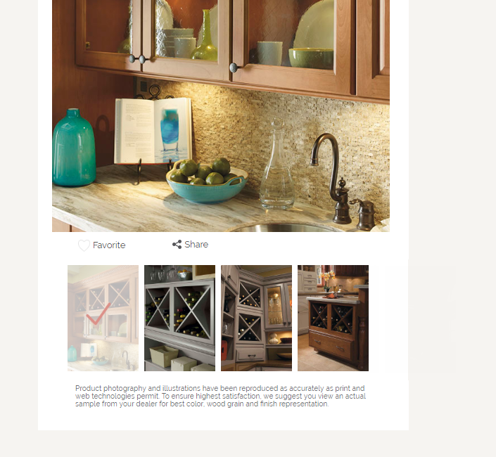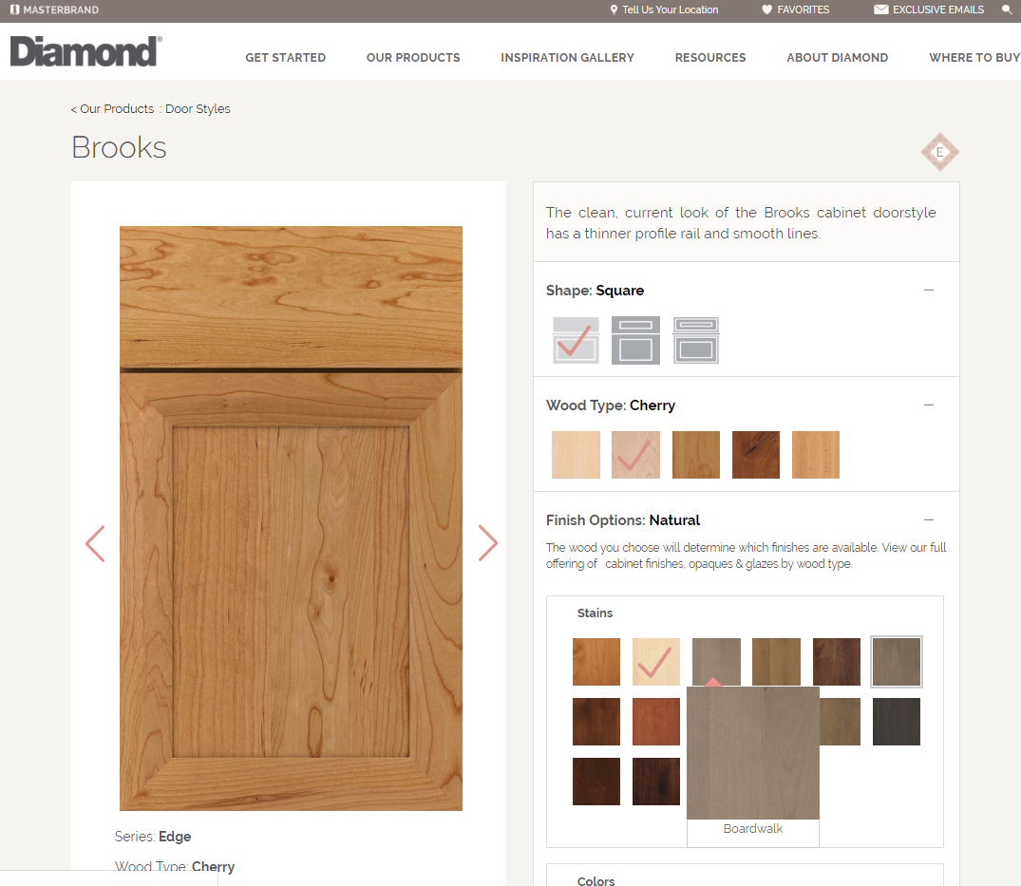

*DiamondCabinetry.com shown to the right for reference/context ONLY. TVL to have its own unique designs created during this project.

Product Detail Pages (.com and .ca) Cont.

**Back-End** **Acceptance Criteria:**

1. Some doors will offer penned glazing, hand wiped glazing, specialty finishes, brushed finishes and semi-translucents; there will need to be a way to manage these finishes separately from each other, as well as separate from the other finishes and opaques.
   1. For the glazes preferably under Global > Attributes > Options > Glazes there would be subcategories for penned and hand wiped.
   2. Sections for penned glazes, hand wiped glazes, specialty finishes, brushed finishes and semi-translucent finishes will also need to be added to the wood type items (/sitecore/templates/User Defined/WebStrategy/Thomasville/Catalog/Wood Type) for these finish options. (some of these may already be present from the SDK project)
2. The functionality requested in front-end item #2 will need to be content manageable, so that the content editor can add to or change the finish types that won’t be visualized. (implement like DAL)
3. The content editor will need the ability to select similar doors on the door node to populate the tab described in front-end item #8. This should function like the Related Products for secondary products. The tab title ‘more doors like this’ should also be content manageable. (implement like DAL)
4. The content editor will need the ability to content manage the titles of the finish categories on the door detail page mentioned in front-end item #2. (stains, opaques, penned glazes, specialty, etc.)
5. The finish addition/deletion scripts need to be updated to accommodate the new finish categories.
6. The disclaimer text is currently managed for all product pages on the Products node, but this will need to change so that finish detail and secondary product detail pages can have slightly different disclaimers.



*DiamondCabinetry.com shown to the right for reference/context ONLY. TVL to have its own unique designs created during this project.

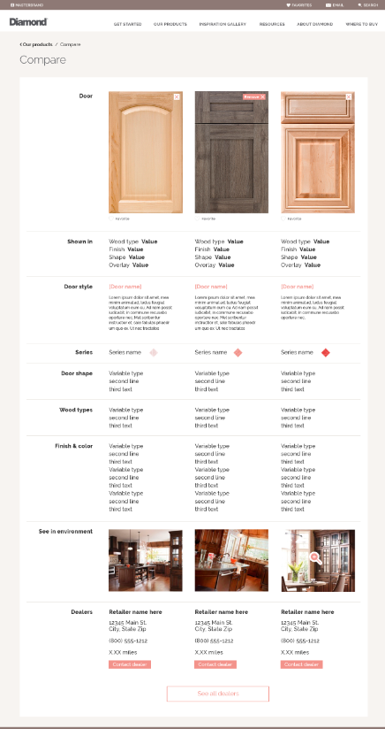Product Compare (.com and .ca)

**Front-End Acceptance Criteria:**

1. TVL product compare pages (door and finish) will also need to be updated to identify which series that product belongs to.
2. A row should be added to the page that identifies the Series, and also has the associated iconography for the series, like on Diamond.
3. The Series
4. This ‘Series’ row should be beneath the ‘Door Style’ row on the door compare page and beneath the ‘Shown In’ row on the finish compare.
5. The finish compare design should be updated to look more like the Diamond finish compare page with the ‘shown in’ row, then the ‘finish’ row which includes the finish name and description, then the ‘series’ row.
6. On the door compare page the logos should be removed from above the door image because we will now address that in the ‘Series’ row.

**Back-End** **Acceptance Criteria:**

1. The row names should be content manageable
   1. For example, ‘Door Style’, ‘Series’, ect.

Site Sync Sites

**Front-End Acceptance Criteria:**

1. Site Sync sites will inherit the styling of the mobile Omega site.
2. The co-branded logo associated on the “Dealer Portal” template will appear instead of the Omega logo.
3. The dealer locator bar will not appear on Site Sync sites, consistent with desktop.
4. Where to Buy in the main menu will be replaced with a Make an Appointment or Contact Us call-to-action, consistent with the desktop version of the Site Sync site.
   1. The Make an Appointment form will not be responsive.

**Back-End** **Acceptance Criteria:**

1. Content should be pulled from the Omega node in Sitecore.
2. When content is updated in Sitecore and published, the mobile site should update as well.
   1. Ex: Adding/deleting pages, changing promo buttons, copy changes, etc. 

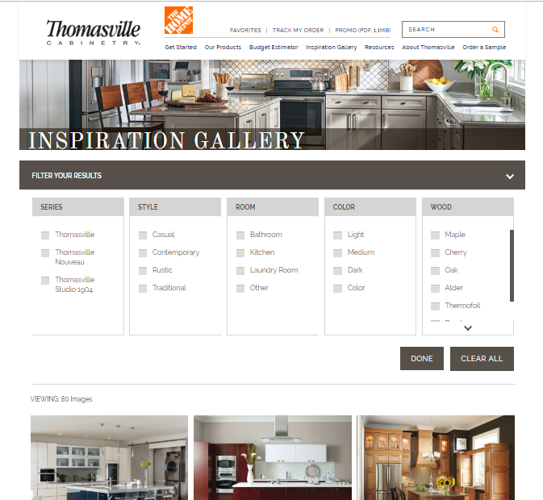 Inspiration Gallery (.com and .ca) 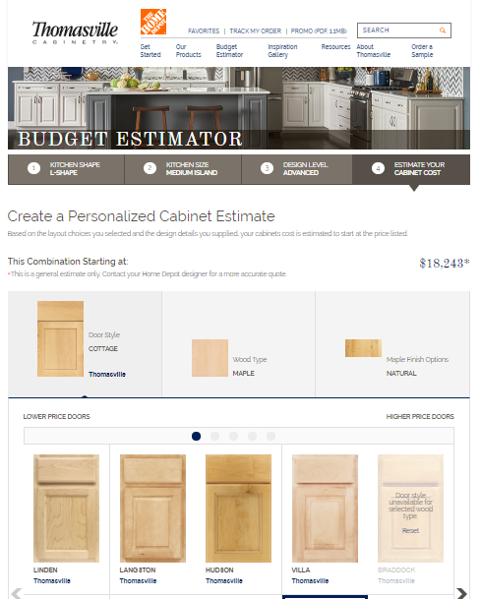Budget Estimator (.com only)

*DiamondCabinetry.com shown to the right for reference/context ONLY. TVL to have its own unique designs created during this project.

**Front-End Acceptance Criteria:**

1. A user should only have to select the “Show More” button once. After that, subsequent pages should utilize lazy load functionality.

**Back-End** **Acceptance Criteria:**

1. There will need to be a way to hyperlink users to any and all pre-filtered views of the gallery (something like http://www.thomasvillecabinetry.com/inspiration-gallery?series=vibe&style=contemporary).

**Front-End Acceptance Criteria:**

1. The Artisan collection/series will need to be added to TVL budget estimator.

**Back-End** **Acceptance Criteria:**

1. All areas that are content manageable today for TVL BE shall remain content manageable with the addition of the areas stated in the TVL BE 2.0 requirements.

Favorites (.com and .ca)

**Front-End Acceptance Criteria:**

1. The Favorites page for TVL will also need to be updated to allow iconography identifying which series a door, finish, room or secondary product is in. (similar to Diamond)
   1. Doors and rooms will only belong to one series, but finishes and secondary products can be in multiple series.
2. The “Print My Favorites” feature of the page should present the user with a print-friendly version of the page with all information laid out in a manner that is organized and easy to follow.
   1. Series icons should also show up in the printed version.

**Back-End** **Acceptance Criteria:**

1. The information presented on this page is dynamically generated, so no content management updates should be needed.
2. Elements that are content manageable today should remain content manageable.

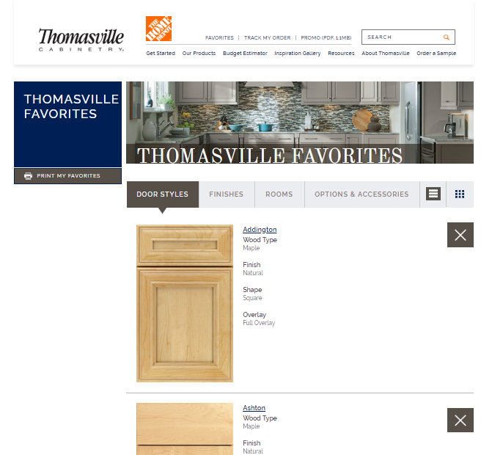

Locator (.com only)

**Front-End Acceptance Criteria:**

1. The current Nouveau Locator (<https://www.thomasvillecabinetry.com/store-locator>) needs to be updated to be a locator that shows all TVL Enterprise brand availability within The Home Depot stores, not just Nouveau.
2. This one locator will list all Home Depot stores and on each location listing will list what series are available in that particular store.
3. On the locator listings a section should be added for ‘Series Available’. This might look similar to the ‘Brands Available’ column on the MasterBrand locator.
4. Filtering functionality is desired, for example:
   1. Show only Home Depot stores that sell Nouveau
   2. Show only Home Depot stores that sell Studio
5. The Design Connect banner should remain on this page.
6. Need the ability to pass query string parameters from product detail pages to the locator so the user sees only stores that sell the product that they are coming from.
   1. The system should be intelligent enough to know the series that each product is available in and therefore know what series to show on the locator if the user is coming from a referring product page.
      1. For example, if I am a user on a Nouveau door detail page and I click on the locator CTA I will be taken to the locator with the ‘Show only Home Depot stores that sell Nouveau’ filter pre-selected. The system should pass along the appropriate parameter from each detail page ensuring that I’m not shown stores where I cannot get my product.

**Back-End** **Acceptance Criteria:**

1. The product offering data from Channel’s spreadsheet will determine what series’ are displayed for a particular Home Depot location.
2. The referring product page URL’s should not have to be manually content managed. The system should reference the series that has been assigned to each product and tell the locator what filters to apply.
3. Everything that is content manageable on this page today should remain content manageable.

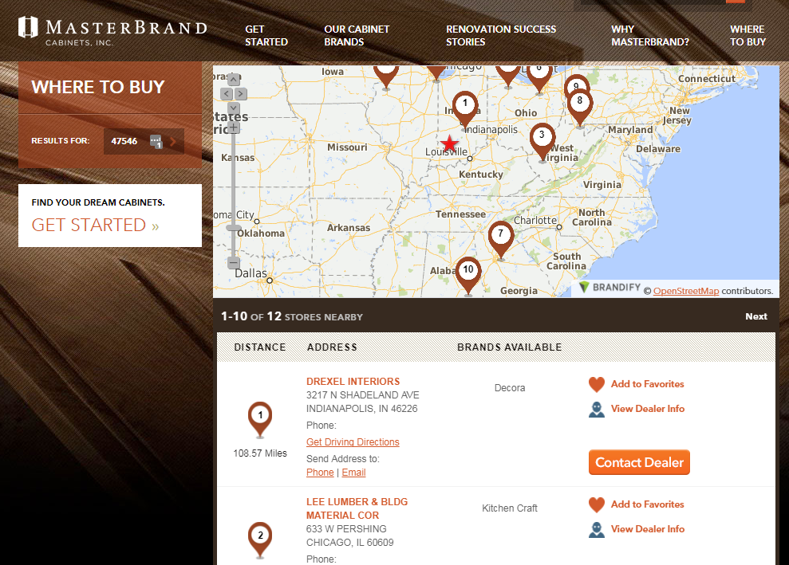

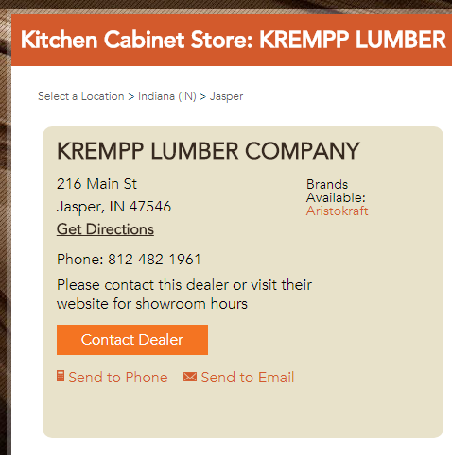

*MasterBrand.com shown to the right for reference/context ONLY. TVL to have its own unique designs created during this project.

Sitecore Enhancements

**Back-End** **Acceptance Criteria:**

1. On TVL we need the ability to insert H3 with General Rich Text and H4 with Image Block templates underneath the Content Page with Flex template.
2. If I right click on the TVL/Products node in Sitecore and go to Insert – Door Style it gives me the wrong door style template: /sitecore/templates/User Defined/WebStrategy/Brands/Pages/Catalog/Door Style
   1. The correct template is: /sitecore/templates/User Defined/WebStrategy/Thomasville/Catalog/Door Style
3. If I right click on a TVL door style (TVL/Products/Darien for example) and go to Insert – Wood Type it gives me the wrong wood type template: /sitecore/templates/User Defined/WebStrategy/Brands/Catalog/Wood Type
   1. The correct template is: /sitecore/templates/User Defined/WebStrategy/Thomasville/Catalog/Wood Type
4. If I right click on a TVL door style (TVL/Products/Crosse for example) and go to Insert – Environment it gives me the wrong environment template: /sitecore/templates/User Defined/WebStrategy/Brands/Catalog/Environment
   1. The correct template is: /sitecore/templates/User Defined/WebStrategy/Thomasville/Catalog/Environment

Content Entry Requirements

Content Entry will have to be done to add the Artisan collection to the TVL website as part of this project. This will include building the products in Sitecore for roughly:

* 2916 door images
* 149 finish images
* 120 secondary products
* 36 room scenes

Performance Requirements

The performance of the website as a whole will need to be improved, particularly the product gallery.

* TVL should perform as well or better than the new SDK websites.



TVL Enterprise Website Redesign – Potentially ‘Phase 2’

Global

The same global requirements that are listed at the beginning of this document also apply for Phase 2.

**PHASE 2 UX / DESIGN:**

1. Visual design will be needed for the following redesigned/enhanced pages:
   1. Our Products Mega Menu
   2. Our Products Landing Page
   3. Product Category Landing Page

Our Products ‘Mega-Menu’ (new) (.com and .ca)

**Front-End Acceptance Criteria:**

1. A ‘Mega-Menu’ should be added to the ‘Our Products’ primary navigation item (see [www.homedepot.com](http://www.homedepot.com) for reference).
2. On desktop the mega-menu will appear when a user hovers over the ‘Our Products’ primary navigation item.
3. If a user clicks on ‘Our Products’ they will be taken to an Our Products landing page.
4. Within the mega menu the 7 product categories will be listed (door styles, finishes, mullion & glass doors, embellishments, specialty cabinets, organization and hardware) These product categories may stack in a single column as depicted in the mockup below if the content manager chooses.
5. Each product category should be clickable with a content manageable link. Upon click these product categories would take the user to the corresponding product category landing page.
6. Beneath each product category ‘header’ will be links like ‘Shop by Series’, ‘Shop by Colors’, etc. These links will also be content manageable.
7. The height of the mega-menu should grow/shrink with the content that is within.
8. Each category column should have the ability to have a ‘call-out’ at the bottom of the category that would include an image, title, copy and a link. This call-out would be optional, could be on/off for any category at any time. The intent is that these call-outs will link to the corresponding product gallery with prefiltered selections based on querysting values. (shown below as ‘Shop Painted Shaker Cabinet Styles’)
9. There should also be a separate column on the far right for a call-out. This call-out should also include an image, title, copy and a link. It would be optional, could be turned on/off at any time. (shown below as ‘Base Toekick Vacuum’)

**Back-End** **Acceptance Criteria:**

1. The product category headings and links should all be content manageable.
2. All sub category links (shop by links) text and links should be content manageable.
3. All call-outs should be content manageable and have the ability to be turned off/on.

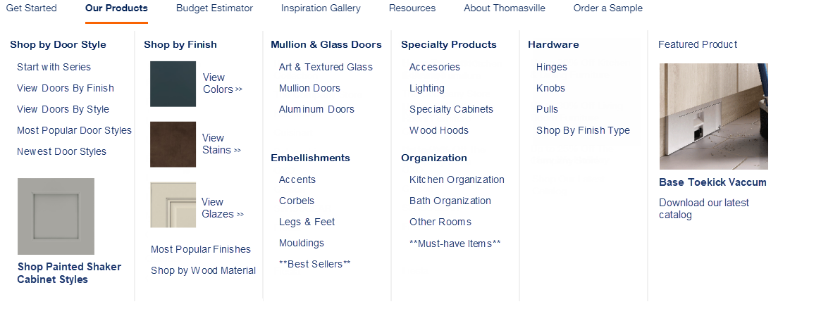

*Mock up shown to the right is for reference/context ONLY, not to be used as an actual design.

**Mobile** **Requirements**:

1. On a mobile device the mega menu should be disabled and if a user taps on Our Products they are taken to the Our Products landing page.
2. This landing page should have a user friendly mobile design (similar to [www.wayfair.com](http://www.wayfair.com)

Our Products – Landing Page (new) (.com and .ca)

*Mock up shown below is for reference/context ONLY. TVL to have its own unique designs created during this project.

**Front-End Acceptance Criteria:**

1. This new page should follow the documented global requirements for page structure.
2. This will be an image centric page that will be used to navigate the user to pre-filtered selections within the respective product gallery.
3. If the user clicks on the ‘Our Products’ primary navigation item they will be taken to the ‘Our Products’ landing page. This page will have sections for each of the 7 product category (door styles, finishes, organization, etc.)
4. The design of the header of this page should be in line with the headers of the other pages on the TVL site.
5. Within each product category section there should be content manageable pods that would each contain an image, title and marketing copy.
6. The product categories on this page should be able to be linked to via hashlinks/anchor links.
7. The intent is for the call to action within each content pod to link to the corresponding product gallery with prefiltered selections based on querystring values.

**Back-End** **Acceptance Criteria:**

1. The product category titles ‘Door Styles’ for example, should have the option to have a link associated to it. Upon click they would be taken directly to the product gallery with that product category selected.
2. Each of the product category section text and links should be content manageable.
3. Each pod within each category should be content manageable. CA should be able to manage the image, title, copy and link for each pod.
4. There should not be a maximum number of pods that can go within a section, as more pods are added they would continue to add rows of pods beneath.

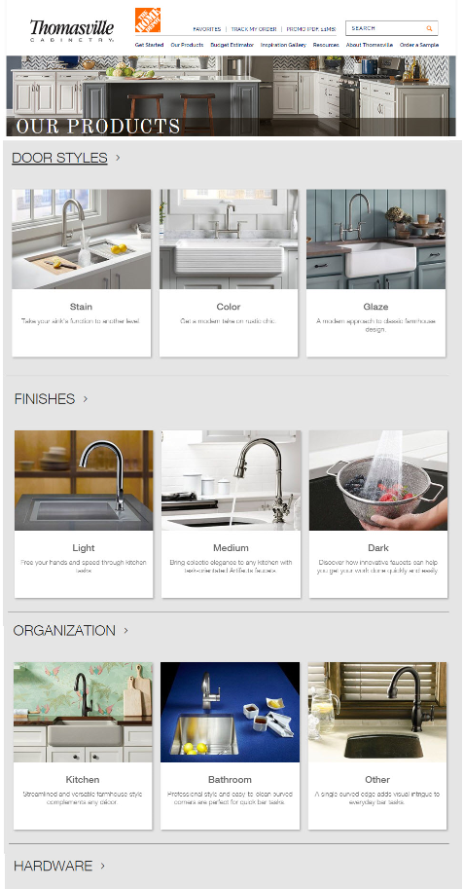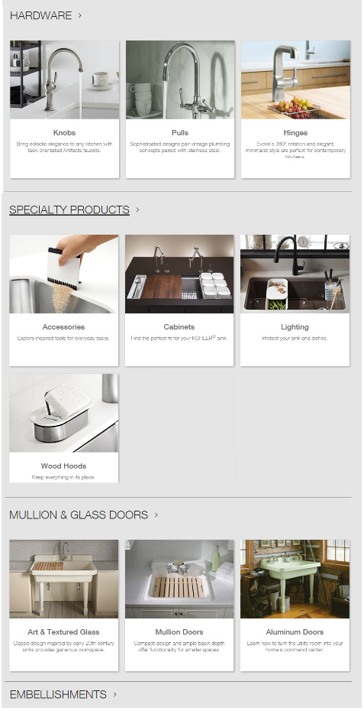

*Mock-up shown to the right is for representation purposes only, not to be used as an actual design.

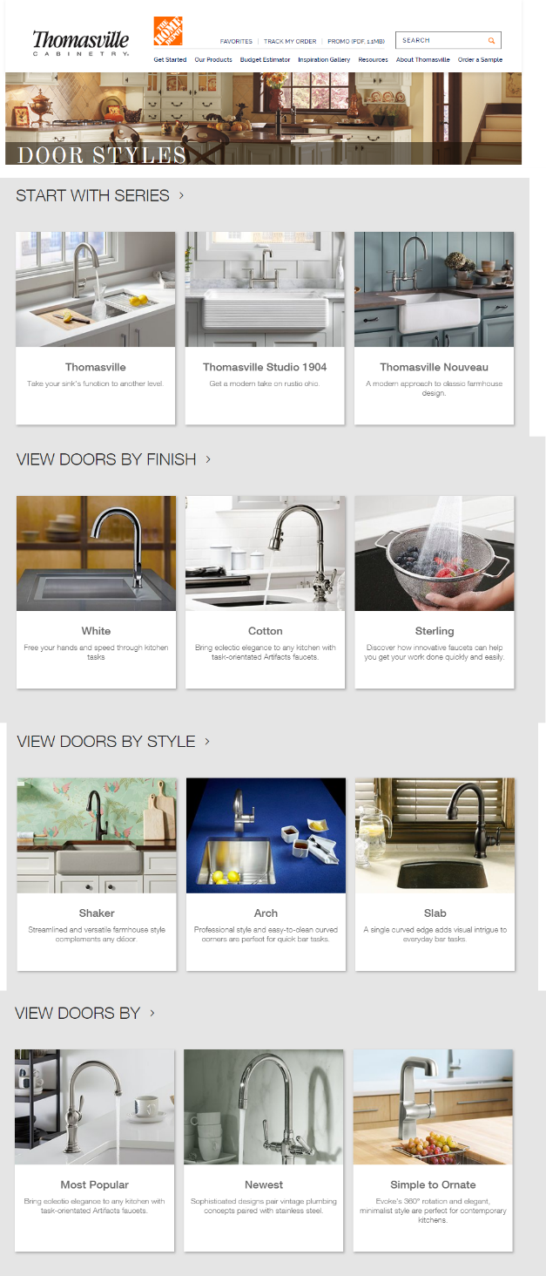Our Products – Category Landing Pages (new) (.com and .ca)

**Front-End Acceptance Criteria:**

1. These new pages should follow the documented global requirements for page structure.
2. These will be image centric pages that will be used to navigate the user to pre-filtered selections within the respective product gallery.
3. If a user clicks on a product category in the mega menu then they will be taken to the product category landing page. For example, the user clicks on the ‘Door Styles’ link within the mega menu, they are then taken to the door styles landing page.
4. There will be separate landing pages for each of the 7 product categories (door styles, finishes, organization, etc.)
5. There should also be an additional landing page for ‘Must Haves’
6. The landing pages will have a category heading, ‘Door Styles’ for example.
7. In addition to the CTA’s within each content block that leads the user to a prefiltered view of that respective product gallery. There should also be a link that says ‘View all Door Styles’ for example.
8. They should have multiple content pods each that have an image, title, copy, and content manageable link. (similar to the sections on the product gallery landing page).
   1. On the door styles category landing page some examples of these pods would be ‘Start with Series, View Doors by Finish, View Doors by Style’ etc.
9. The design of the header of this page should be in line with the headers of the other pages on the TVL site.
10. The categories/sections on this page should be able to be linked to via hashlinks/anchor links.

**Back-End** **Acceptance Criteria:**

1. All product category titles should be content manageable.
2. All images, copy and links on these pages should be content manageable.

*Mock up shown to the right is for reference/context ONLY, not to be used as an actual design.

Our Products – Product Gallery Enhancements (.com and .ca)

**Front-End Acceptance Criteria:**

1. ~~A new ‘Top Finishes’ filter will need to be added to the door style gallery. The user will only be able to select one finish at a time.~~
   1. ~~A swatch for default/no selection will appear first and be selected. This will present the page as it is configured today.~~
   2. ~~When a user selects one of these finishes (white for example) the product gallery door images will update and show~~ **~~all~~** ~~doors that are available in White.~~
   3. ~~The selected finish should have an active border around it, similar to what is seen on the door detail pages.~~
   4. ~~If a door is available in Maple white but there is no door image available then that door will not be shown.~~
   5. ~~Doors will be grouped by wood type (similar to how the door gallery looks if you select more than one wood type filter).~~
   6. ~~The order that the wood types appear will mimic the order the wood types are listed in the wood type filter area. For example, if the user selects the top finish White they will be shown ‘White on Maple’ doors first then ‘White on PureStyle’ doors. The category header should update accordingly as shown in the mock-up on the right. (White on Maple)~~
   7. ~~If the user also selects wood types within the wood type filter then only those wood types would show. For example, as a user I could select Wood type: PureStyle and Top Finish: White, at that time I would only see ‘White on PureStyle’ doors in the gallery.~~
   8. ~~There should be a content manageable link at the bottom of this filter box that says something like ‘see all finishes’ that would take the user to the finishes gallery.~~
2. The Brand filter should be changed from a radio button to a check box allowing the user to select more than one brand at a time. If no brand is selected the user will see ALL brands together.
3. Another new filter should be added to the door style gallery: ‘Door Design Style’ (name to change):
   * + - The attributes for this filter are yet to be determined but may be something like: Beadboard, Flat Panel (aka Recessed Panel), Raised Panel, Shaker Attributes should be content manageable in the global folder.

*Could be managed as secondary style attributes (e.g. Shaker is recessed and square)

1. A clear all button will need to be introduced to clear the users filter selections (category will always remain selected, these should not clear)
2. Filter ‘bread crumbs’ will need to be introduced to let a user know what filters they have selected at all times. A user should not be able to ‘X’ out of the category filter because those should remain checked at all times.
3. A new filter will need to be added to the Organization gallery called ‘Must Haves’
   1. The attributes for this filter are yet to be determined but may be something like: Gourmet, Traditional, etc. Attributes should be content manageable in the global folder.

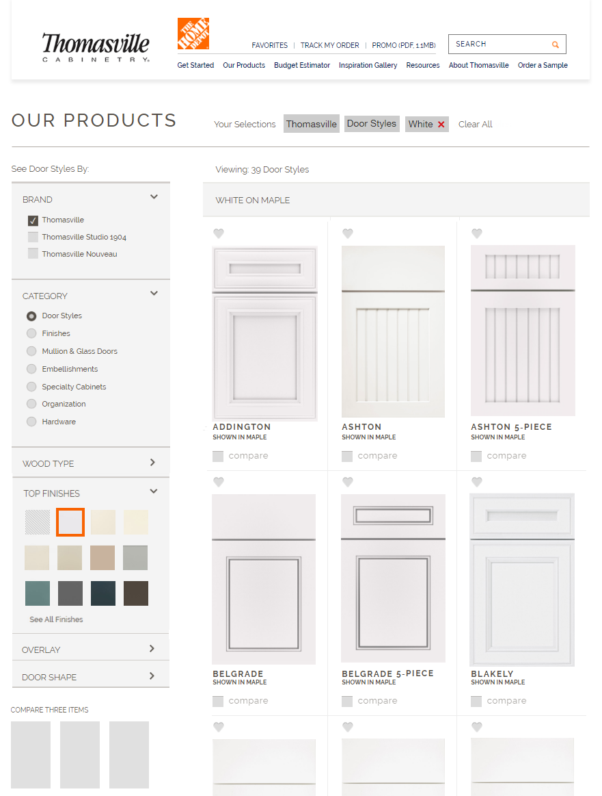

*Mock up shown to the above is for reference/context ONLY, not to be used as an actual design.

Our Products – Product Gallery Enhancements Cont. (.com and .ca)

1. Would like to add a place at the top of the products gallery to call out products or have ‘banner ads’ within the gallery as the user scrolls down the page. Something like what is shown here: <https://www.us.kohler.com/us/browse/kitchen-bar-sink-faucets/_/N-2d8v>

**Back-End** **Acceptance Criteria:**

1. ~~The content author will need to have a way to manage the ‘Top Finishes’ that appear within the top finishes filter mentioned in FE requirement #1. The content author should be able to easily reorder these or change them out at any time.~~
   1. ~~The link and link text at the bottom of the finishes filter area ‘see all finishes’ should be content manageable.~~
2. There will need to be a multi select box added to the door style template so the content author can tag a door style with multiple ‘door design styles’.
3. A new attribute will need to be added to the organization template for ‘must have’ – this should be a multi select box.

Acceptance Sign-Off

Signature denotes official acceptance of document content and approval of release as a MasterBrand Cabinets Inc. published document. All content is considered current, authentic, complete and accurate. Approver(s) acknowledge that requests not mentioned in this document will be considered a change and will be subject to an executive approved change order. A change request may impact timeline or budget.

|  |  |  |  |  |
| --- | --- | --- | --- | --- |
|  |  | Digital Marketing Manager |  |  |
| Brian Taylor |  | Title |  | Date |
|  |  | Brand Manager |  |  |
|  |  | Title |  | Date |

|  |  |  |  |  |
| --- | --- | --- | --- | --- |
|  |  | Channel Manager |  |  |
|  |  | Title |  | Date |
|  |  | Business Analyst |  |  |
|  |  | Title |  | Date |